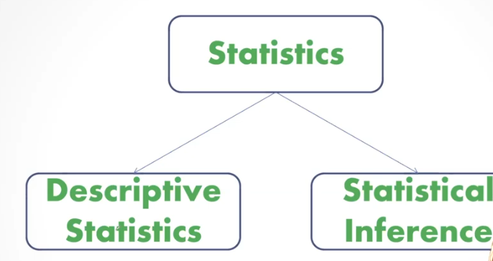

Most of the EDA that we do is on the descriptive statistics area

Statistical Inference is basically a journey from sample to population

We do all kinds of analysis on the sample but ultimately our aim is to go back to the population

The journey is from the sample to the population and from the population to the sample

It is not the sample that we are interested. We are more interested in the population

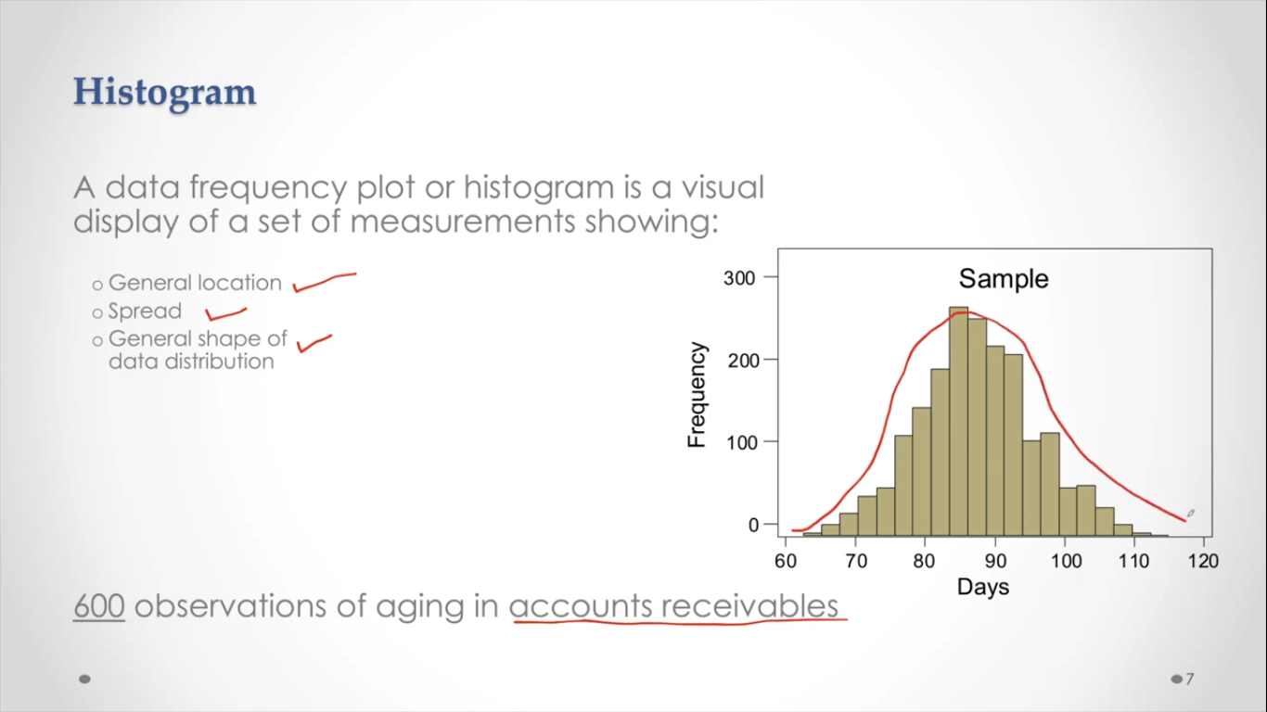

“Accounts receivable (AR) is **the balance of money due** to a firm for goods or services delivered or used but not yet paid for by customers”

**General location: -**

1. See where the values are really concentrated. Usually they are captured by mean, median mode
2. Mean is a very good measure if data is symmetric
3. If the data is skewed usually people go with median
4. Histogram will give you some idea where the general location is

**Spread: -**

**The spread of the data is from 60 days to 115 days**

**The range of these account receivables so that much time this is taking**

**Shape: -**

**The shape of the histogram looks like a symmetric pattern**

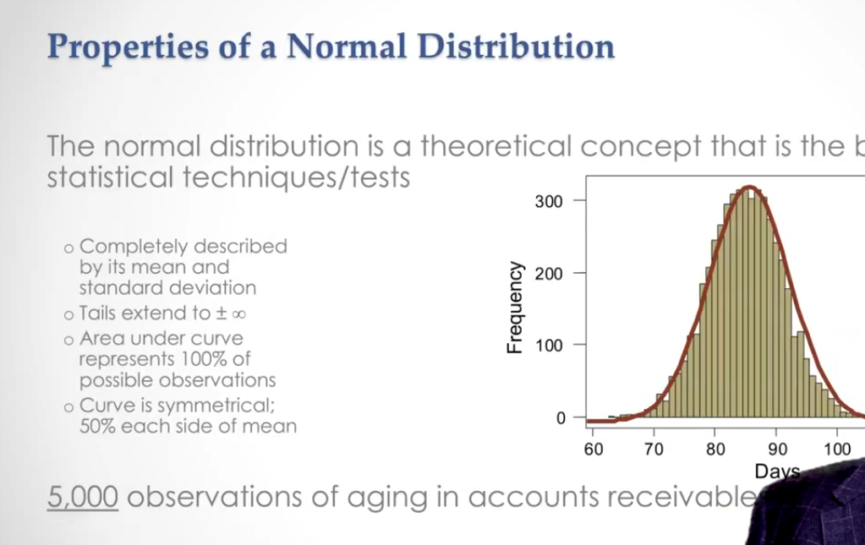

**The normal distribution can be completely described by two parameters**

**One is mean and the other is standard deviation**

**The curve gets closer and closer to x axis, but it never meets x axis**

**And the area under the total curve is 100% or in terms of probability it is one**

**It’s symmetric if you cut it into half**

**Left half it has 50% area and right half it has 50% area**

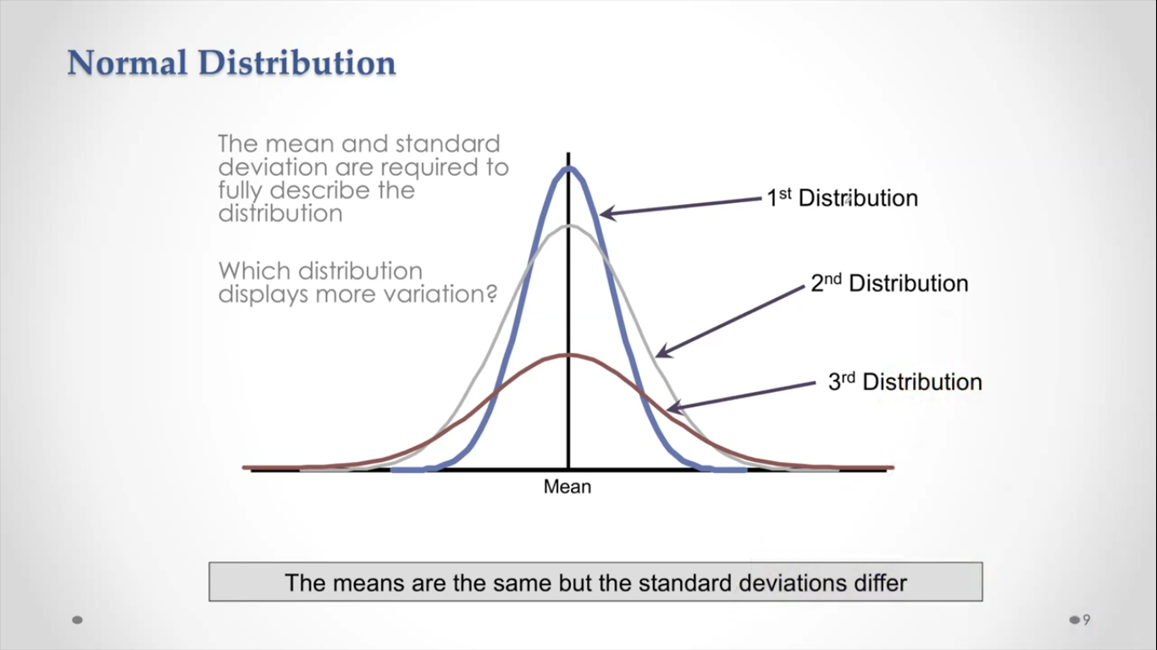

**The mean and standard deviation can change the shape of the normal distribution**

**The blue one has the lowest variability and the brown one has the highest variability**

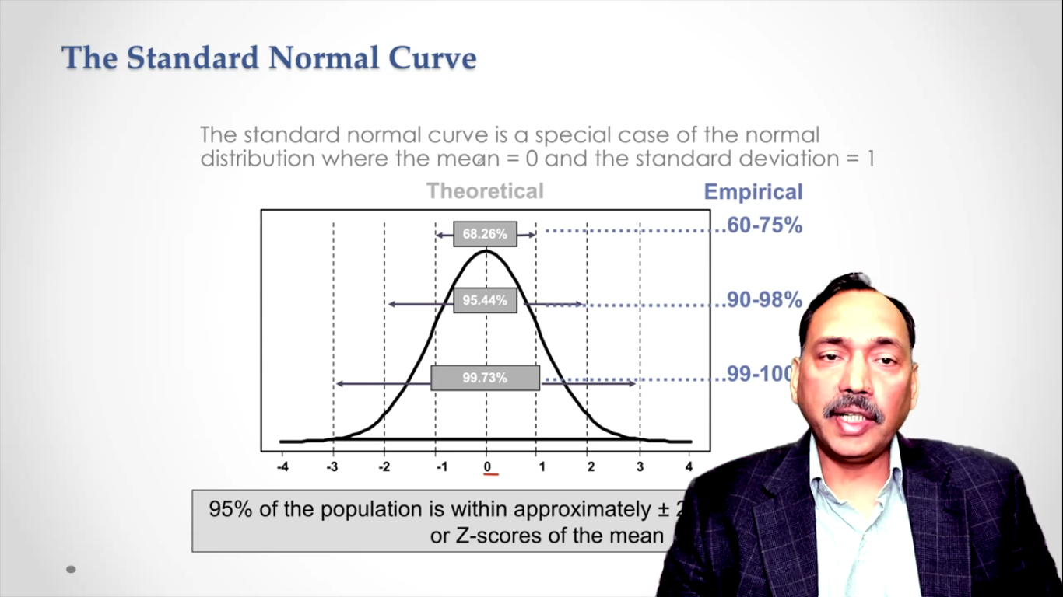

**This is a standard normal distribution with mean 0 and standard deviation 1**

**68.26% of the area is covered under +-1**

**The area between -+2 is 95.44%**

**The standard deviation distance from -+3 is 99.73% almost 100**

**We never get these beautiful normal distribution curves in real life**

**The x axis is z axis/ z scores**

**Z stands for standard normal distribution**

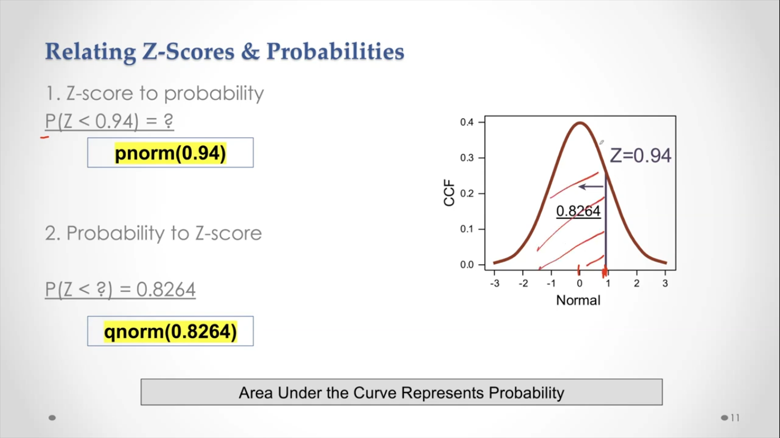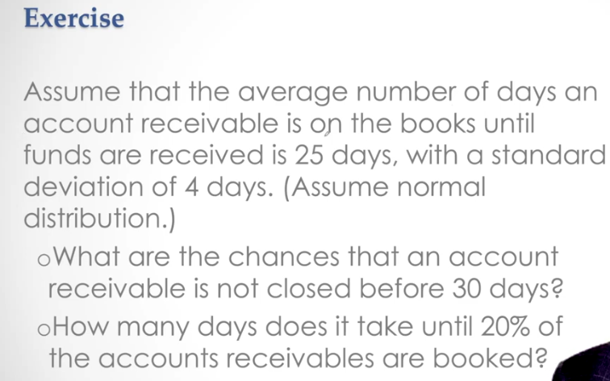

**Look at the code file**

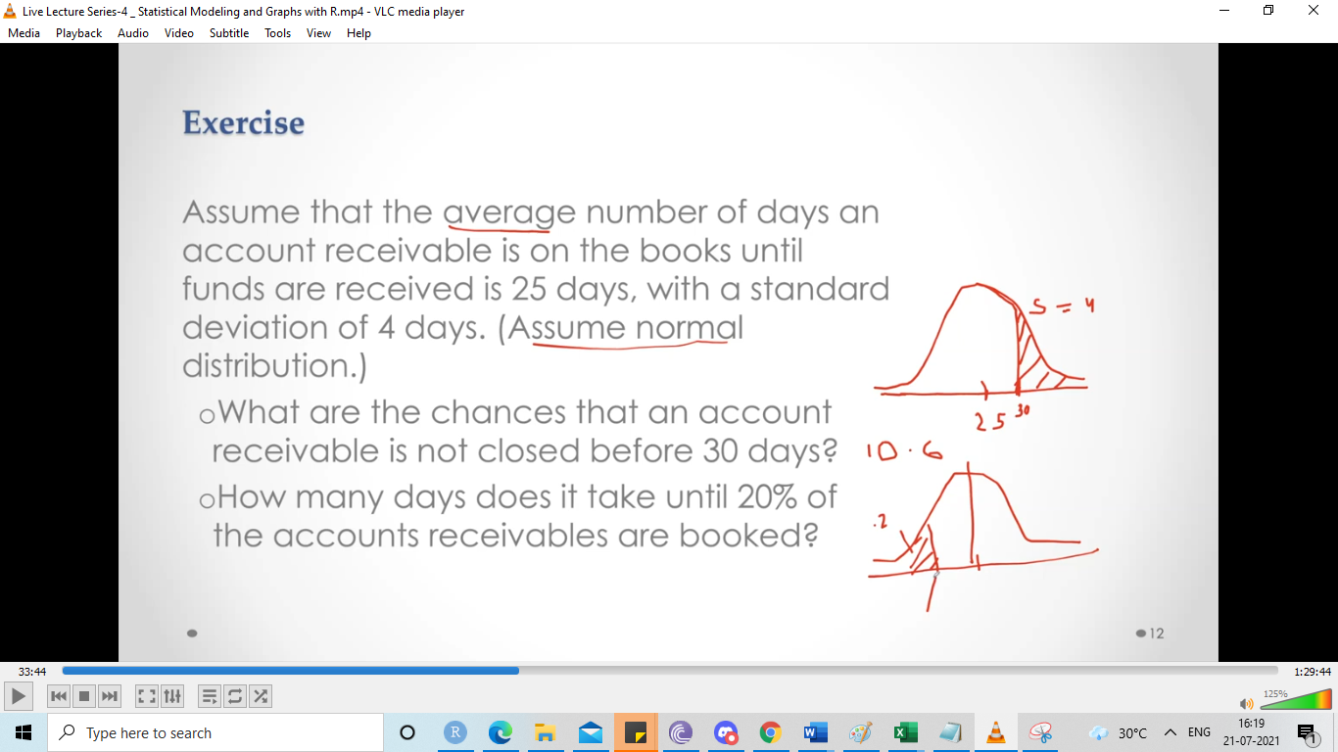

Suppose IQs are normally distributed with a mean of 100 and a standard deviation of 15

What IQ separates the lower 25% from the others?

What IQ separates the top 10% from the others?

What percentage of people have IQ less than 125?

